Green Pace Developer: Security Policy Guide Template



Green Pace Secure Development Policy

Contents
Overview 2
Purpose 2
Scope 2
Module Three Milestone 2
Ten Core Security Principles 2
C/C++ Ten Coding Standards 3
Coding Standard 1 4
Coding Standard 2 5
Coding Standard 3 6
Coding Standard 4 7
Coding Standard 5 8
Coding Standard 6 9
Coding Standard 7 10
Coding Standard 8 11
Coding Standard 9 12
Coding Standard 10 13
Defense-in-Depth Illustration 14
Project One 14
1. Revise the C/C++ Standards 14
2. Risk Assessment 14
3. Automated Detection 14
4. Automation 14
5. Summary of Risk Assessments 15
6. Create Policies for Encryption and Triple A 15
7. Map the Principles 16
Audit Controls and Management 17
Enforcement 17
Exceptions Process 17
Distribution 18
Policy Change Control 18
Policy Version History 18
Appendix A Lookups 18
Approved C/C++ Language Acronyms 18

Overview
Software development at Green Pace requires consistent implementation of secure principles to all developed applications. Consistent approaches and methodologies must be maintained through all policies that are uniformly defined, implemented, governed, and maintained over time.

Purpose
This policy defines the core security principles; C/C++ coding standards; authorization, authentication, and auditing standards; and data encryption standards. This article explains the differences between policy, standards, principles, and practices (guidelines and procedure): Understanding the Hierarchy of Principles, Policies, Standards, Procedures, and Guidelines.

Scope
This document applies to all staff that create, deploy, or support custom software at Green Pace.

Module Three Milestone

Ten Core Security Principles
Principles | Write a short paragraph explaining each of the 10 principles of security.
- Validate Input Data | Always check the data users enter to make sure it’s safe and correct. This helps to stop hackers from entering harmful code, like login or search boxes.
- Heed Compiler Warnings | When your code shows warnings, don’t ignore them. These warnings can point out small problems that could turn into bigger security issues later.
- Architect and Design for Security Policies | Think about security from the beginning when designing a program. Planning ahead helps keep your system safe and avoids problems down the line.
- Keep It Simple | The simpler your code is, the easier it is to understand and protect. Complicated code can hide bugs or mistakes that hackers might use.
- Default Deny | Don’t allow access unless it’s clearly needed, start with everything blocked, and then only allow what’s absolutely necessary.
- Adhere to the Principle of Least Privilege | Give users and programs the smallest amount of access they need to do their job. That way, if something goes wrong, the damage is limited.
- Sanitize Data Sent to Other Systems | Before sending data to another system or app, clean it up. This stops harmful code from being passed along and used in an attack.
- Practice Defense in Depth | Use multiple layers of security. If one layer fails, another one can still protect the system. It’s like having both a lock and an alarm on your door.
- Use Effective Quality Assurance Techniques | Test your code carefully to catch problems early. Things like code reviews and testing tools can help find bugs before hackers do.
- Adopt a Secure Coding Standard | Follow a set of rules when writing code to make sure it’s safe. These rules help everyone on the team write code that avoids common security mistakes.

C/C++ Ten Coding Standards
Complete the coding standards portion of the template according to the Module Three milestone requirements. In Project One, follow the instructions to add a layer of security to the existing coding standards. Please start each standard on a new page, as they may take up more than one page. The first seven coding standards are labeled by category. The last three are blank so you may choose three additional standards. Be sure to label them by category and give them a sequential number for that category. Add compliant and noncompliant sections as needed to each coding standard.

Coding Standard 1

Coding Standard | Label | Name of Standard
Data Type | [STD-001-INT] | Avoid using int for loop counters when precision matters. Using int for loop counters can lead to overflow or incorrect behavior when handling large data sets. Using size _t matches the container’s type and avoid type mismatch issues.

Noncompliant Code
Using int for loop counters can overflow or cause unexpected behavior if data size is large
For (int i=0; i<data.size();++i) {
Process(data[i]);
}

Compliant Code
Using std::size_t is safer and matches the containers type and avoids overflow
For (std::size_t i=0; i<data.size();++i){
Process(data[i]);
}

Note: Stop here for the milestone. Complete this section for Project One in Module Six.
Principles(s): Principle 3- Prevent numeric errors

Threat Level
Severity | Likelihood | Remediation Cost | Priority | Level
HIGH | Likely | Low | 1 | 1

Automation
Tool | Version | Checker | Description Tool
SonarQube | 10.2 | Cpp:S881 | Detects possible unsigned integer wraparound during arithmetic
Clang-Tidy | 15.0 | Cert-int30-c | Warns about unsigned integer operations that may wrap around
[Insert text.] | [Insert text.] | [Insert text.] | [Insert text.]
[Insert text.] | [Insert text.] | [Insert text.] | [Insert text.]
Coding Standard 2

Coding Standard | Label | Name of Standard
Data Value | [STD-002-VAL] | Check for integer overflow before arithmetic operations. Integer overflow can lead to security flaws or incorrect results. Checking before performing arithmetic prevents this.

Noncompliant Code
No check for overflow on multiplication.
Int result = a*b;

Compliant Code
Checks multiplication won’t overflow.
If (b !=0 && a>INT_MAX/b) {
//handle error
} else {
Int result=a*b;
}

Note: Stop here for the milestone. Complete this section for Project One in Module Six.
Principles(s): Principle 3-Prevent numeric errors

Threat Level
Severity | Likelihood | Remediation Cost | Priority | Level
HIGH | Unlikely | Low | 2 | 1

Automation
Tool | Version | Checker | Description Tool
SonarQube | 10.2 | Cpp:S881 | Detects possible signed integer overflow
Clang-Tidy | 15.0 | Cert-int32-c | Ensures signed integers are checked before arithmetic operations
[Insert text.] | [Insert text.] | [Insert text.] | [Insert text.]
[Insert text.] | [Insert text.] | [Insert text.] | [Insert text.]

Coding Standard 3

Coding Standard | Label | Name of Standard
String Correctness | [STD-003-STR] | Avoid using unsafe string functions like gets() and strcpy(). Some strings functions don’t check how big the data is, which can lead to memory problems or even crashes. It’s safer to use functions that check size.

Noncompliant Code
Gets () doesn’t check the size of the input
Char name [10];
Gets(name);

Compliant Code
Fgets () checks the size and prevents overflows
Char name [10];
Fgets (name, sizeof(name), stdin);

Note: Stop here for the milestone. Complete this section for Project One in Module Six.
Principles(s): Principle 4- Prevent buffer overflows

Threat Level
Severity | Likelihood | Remediation Cost | Priority | Level
HIGH | Likely | Medium | 3 | 1

Automation
Tool | Version | Checker | Description Tool
SonarQube | 10.2 | Cpp:S107 | Detects unsafe string operations and potential buffer overflows
Clang-Tidy | 15.0 | Cppcoreguidelines-pro-bounds-array-to-pointer-decay | Warns when strings exceed allocated memory
[Insert text.] | [Insert text.] | [Insert text.] | [Insert text.]
[Insert text.] | [Insert text.] | [Insert text.] | [Insert text.]

Coding Standard 4

Coding Standard | Label | Name of Standard
SQL Injection | [STD-004-SQL] | Use parameterized queries instead of string concatenation. Combining strings to build SQL queries can let attackers run harmful code. Using parameters makes it safer.

Noncompliant Code
User input is directly added to the query
Std::string query=’SELECT * FROM users WHERE name= ‘ “” + name + “”’;

Compliant Code
Prepared statements safely insert user input
Stmt->prepare (“SELECT * FROM users WHERE name=?”);
Stmt->bind-param(“s”,name);

Note: Stop here for the milestone. Complete this section for Project One in Module Six.
Principles(s): Principle 1- Validate all inputs; Principle 2 – Protect data integrity and confidentiality

Threat Level
Severity | Likelihood | Remediation Cost | Priority | Level
HIGH | Likely | Medium | 4 | 1

Automation
Tool | Version | Checker | Description Tool
SonarQube | 10.2 | Cpp:S3649 | Detects unsafe SQL queries from concatenated input
CodeQL | Latest | Sql-injection | Identifies unparameterized queries vulnerable to SQL injection
[Insert text.] | [Insert text.] | [Insert text.] | [Insert text.]
[Insert text.] | [Insert text.] | [Insert text.] | [Insert text.]

Coding Standard 5

Coding Standard | Label | Name of Standard
Memory Protection | [STD-005-MEM] | Always initialize pointers before using them. If you use a pointer without setting it first, it could point anywhere, which may crash the program or cause a security problem.

Noncompliant Code
Pointer is used without being set.
Int *ptr;
*ptr=5;

Compliant Code
Pointer is initialized before use.
Int value=5;
Int *ptr=&value;

Note: Stop here for the milestone. Complete this section for Project One in Module Six.
Principles(s): Principle 6 – Manage memory securely

Threat Level
Severity | Likelihood | Remediation Cost | Priority | Level
HIGH | Likely | Medium | 5 | 1

Automation
Tool | Version | Checker | Description Tool
SonarQube | 10.2 | Cpp:S3584 | Flags mismatched allocation and deallocation
Clang-Tidy | 15.0 | Cert-mem35-cpp | Detects memory leaks and mismatched free/delete usage
[Insert text.] | [Insert text.] | [Insert text.] | [Insert text.]
[Insert text.] | [Insert text.] | [Insert text.] | [Insert text.]

Coding Standard 6

Coding Standard | Label | Name of Standard
Assertions | [STD-006-ASS] | Do not use assert() for input validation. Assertions are turned off in release builds, so they should not be used to check user input or critical conditions.

Noncompliant Code
assert () should not be used for checking user input
assert (age>0);

Compliant Code
Use if-statement for runtime input checks
If(age<=0) {
Std::cerr<< “Invalid age”;
}

Note: Stop here for the milestone. Complete this section for Project One in Module Six.
Principles(s): Principle 7- Ensure proper error handling

Threat Level
Severity | Likelihood | Remediation Cost | Priority | Level
Medium | Likely | Low | 6 | 2

Automation
Tool | Version | Checker | Description Tool
SonarQube | 10.2 | Cpp:S3234 | Detects assert() calls in release code
Clang-Tidy | 15.0 | Cert-msc30-c | Warns when assert() is used for runtime error checking
[Insert text.] | [Insert text.] | [Insert text.] | [Insert text.]
[Insert text.] | [Insert text.] | [Insert text.] | [Insert text.]

Coding Standard 7

Coding Standard | Label | Name of Standard
Exceptions | [STD-007-EXP] | Always catch specific exceptions instead of using a catch-all. Catching specific exceptions makes it easier to handle problems correctly. Catching everything can hide bugs or important errors.

Noncompliant Code
Catch-all hides the actual error.
Try {
riskyFunction();
} catch (…) {
Std::cerr << “Something went wrong”;
}

Compliant Code
Catches and handles known error types.
Try {
riskyFunction();
} catch (const std::runtime_error& e) {
std::cerr << e. what();
}

Note: Stop here for the milestone. Complete this section for Project One in Module Six.
Principles(s): Principle 7- Ensure proper error handling; Principle 8- Maintain availability

Threat Level
Severity | Likelihood | Remediation Cost | Priority | Level
HIGH | Likely | Low | 7 | 1

Automation
Tool | Version | Checker | Description Tool
SonarQube | 10.2 | Cpp:S106 | Detects catch blocks that fail to handle exceptions
Clang-Tidy | 15.0 | Cert-err51-cpp | Flags unhandled exceptions in C++ code
[Insert text.] | [Insert text.] | [Insert text.] | [Insert text.]
[Insert text.] | [Insert text.] | [Insert text.] | [Insert text.]

Coding Standard 8

Coding Standard | Label | Name of Standard
Null Checks | [STD-008-NUL] | Always check pointers for null before using them. Using a null pointer causes crashes. It’s important to check if a pointer is valid before accessing it.

Noncompliant Code
Pointer is used without checking if its null.
Std::cout<<ptr->value;

Compliant Code
Checks if pointer is not null before using it
If (ptr != nullptr) {
std::cout<<ptr->value;
}

Note: Stop here for the milestone. Complete this section for Project One in Module Six.
Principles(s): Principle 2 – Protect data integrity; Principle 8- Maintain availability

Threat Level
Severity | Likelihood | Remediation Cost | Priority | Level
HIGH | Likely | Low | 8 | 1

Automation
Tool | Version | Checker | Description Tool
SonarQube | 10.2 | Cpp:S2259 | Detects potential null pointer dereferences
Clang-Tidy | 15.0 | Cert-exp34-c | Warns when a pointer may be null before dereferencing
[Insert text.] | [Insert text.] | [Insert text.] | [Insert text.]
[Insert text.] | [Insert text.] | [Insert text.] | [Insert text.]

Coding Standard 9

Coding Standard | Label | Name of Standard
Bounds checking | [STD-009-BOU] | Always check array bounds before accessing elements. Going outside the array size can lead to crashes or let attackers mess with your program. Always check the size first.

Noncompliant Code
Accesses array without checking index
Int val = arr[i];

Compliant Code
Checks index is within valid range
If (i>=0 && i<size) {
Int val = arr[i];
}

Note: Stop here for the milestone. Complete this section for Project One in Module Six.
Principles(s): Principle 4- Prevent buffer overflows; Principle 2: Protect data integrity

Threat Level
Severity | Likelihood | Remediation Cost | Priority | Level
High | Likely | Medium | 9 | 1

Automation
Tool | Version | Checker | Description Tool
SonarQube | 10.2 | Cpp:S3516 | Detects potential out-of-bounds accesses
Clang-Tidy | 15.0 | Cert-arr30-c | Warns when pointers or subscripts exceed array boundaries
[Insert text.] | [Insert text.] | [Insert text.] | [Insert text.]
[Insert text.] | [Insert text.] | [Insert text.] | [Insert text.]

Coding Standard 10

Coding Standard | Label | Name of Standard
Comment Clarity | [STD-010-COM] | Use comments to explain confusing or unclear code. Well-written comments make code easier to understand and safer to maintain. Skipping comments can cause mistakes later.

Noncompliant Code
No comment explaining why code checks specific value
If (code == 42) {
runProcess();
}

Compliant Code
Includes comment explaining why condition is important
//42 is the default access level for admins
If (code == 42) {
runProcess();
}

Note: Stop here for the milestone. Complete this section for Project One in Module Six.
Principles(s): Principle 9-Maintain code clarity; Principle 2- Protect data integrity

Threat Level
Severity | Likelihood | Remediation Cost | Priority | Level
Medium | Likely | Low | 10 | 3

Automation
Tool | Version | Checker | Description Tool
SonarQube | 10.2 | Cpp:S117 | Detects duplicate variable names in inner scopes
Clang-Tidy | 15.0 | Cert-dcl50-cpp | Flags reuse of variable names in nested scopes
[Insert text.] | [Insert text.] | [Insert text.] | [Insert text.]
[Insert text.] | [Insert text.] | [Insert text.] | [Insert text.]
Defense-in-Depth Illustration
This illustration provides a visual representation of the defense-in-depth best practice of layered security.

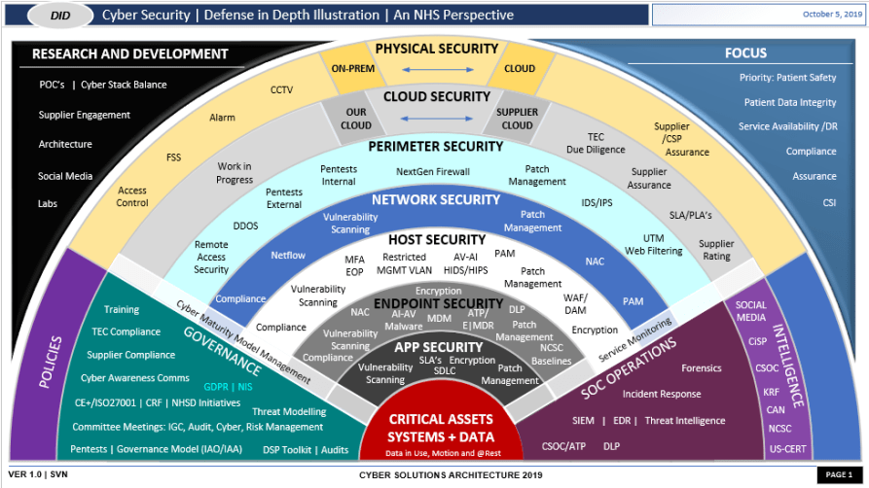

Project One
There are seven steps outlined below that align with the elements you will be graded on in the accompanying rubric. When you complete these steps, you will have finished the security policy.

Revise the C/C++ Standards
You completed one of these tables for each of your standards in the Module Three milestone. In Project One, add revisions to improve the explanation and examples as needed. Add rows to accommodate additional examples of compliant and noncompliant code. Coding standards begin on the security policy.

Risk Assessment
Complete this section on the coding standards tables. Enter high, medium, or low for each of the headers, then rate it overall using a scale from 1 to 5, 5 being the greatest threat. You will address each of the seven policy standards. Fill in the columns of severity, likelihood, remediation cost, priority, and level using the values provided in the appendix.

Automated Detection
Complete this section of each table on the coding standards to show the tools that may be used to detect issues. Provide the tool name, version, checker, and description. List one or more tools that can automatically detect this issue and its version number, name of the rule or check (preferably with link), and any relevant comments or description—if any. This table ties to a specific C++ coding standard.

Automation
Provide a written explanation using the image provided.
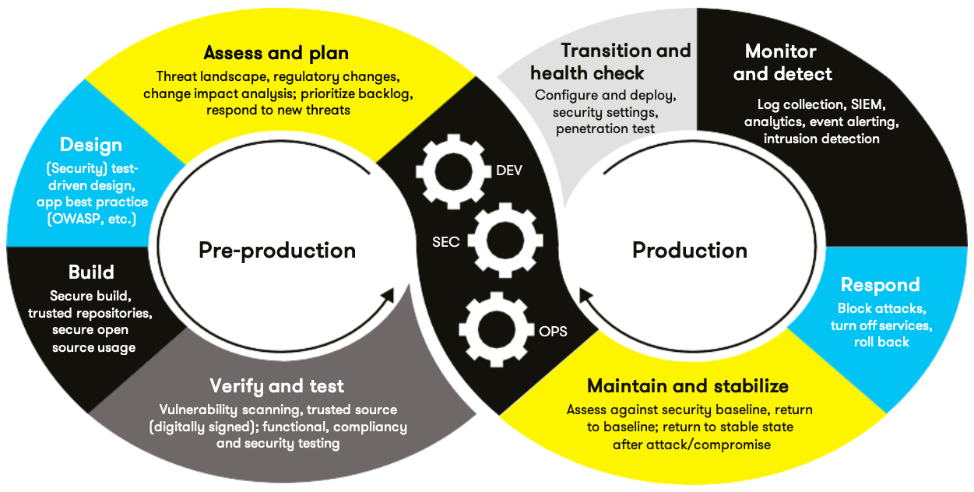

Automation will be used for the enforcement of and compliance to the standards defined in this policy. Green Pace already has a well-established DevOps process and infrastructure. Define guidance on where and how to modify the existing DevOps process to automate enforcement of the standards in this policy. Use the DevSecOps diagram and provide an explanation using that diagram as context.

[Insert your written explanations here.]

Summary of Risk Assessments
Consolidate all risk assessments into one table including both coding and systems standards, ordered by standard number.

Rule | Severity | Likelihood | Remediation Cost | Priority | Level
STD-001-CPP | High | Unlikely | Medium | High | 2
[Insert text.] | [Insert text.] | [Insert text.] | [Insert text.] | [Insert text.] | [Insert text.]
[Insert text.] | [Insert text.] | [Insert text.] | [Insert text.] | [Insert text.] | [Insert text.]
[Insert text.] | [Insert text.] | [Insert text.] | [Insert text.] | [Insert text.] | [Insert text.]
[Insert text.] | [Insert text.] | [Insert text.] | [Insert text.] | [Insert text.] | [Insert text.]
[Insert text.] | [Insert text.] | [Insert text.] | [Insert text.] | [Insert text.] | [Insert text.]
[Insert text.] | [Insert text.] | [Insert text.] | [Insert text.] | [Insert text.] | [Insert text.]
[Insert text.] | [Insert text.] | [Insert text.] | [Insert text.] | [Insert text.] | [Insert text.]
[Insert text.] | [Insert text.] | [Insert text.] | [Insert text.] | [Insert text.] | [Insert text.]
[Insert text.] | [Insert text.] | [Insert text.] | [Insert text.] | [Insert text.] | [Insert text.]
[Insert text.] | [Insert text.] | [Insert text.] | [Insert text.] | [Insert text.] | [Insert text.]
[Insert text.] | [Insert text.] | [Insert text.] | [Insert text.] | [Insert text.] | [Insert text.]
[Insert text.] | [Insert text.] | [Insert text.] | [Insert text.] | [Insert text.] | [Insert text.]
[Insert text.] | [Insert text.] | [Insert text.] | [Insert text.] | [Insert text.] | [Insert text.]

Create Policies for Encryption and Triple A
Include all three types of encryption (in flight, at rest, and in use) and each of the three elements of the Triple-A framework using the tables provided.
  - Explain each type of encryption, how it is used, and why and when the policy applies.
  - Explain each type of Triple-A framework strategy, how it is used, and why and when the policy applies.

Write policies for each and explain what it is, how it should be applied in practice, and why it should be used.

- Encryption | Explain what it is and how and why the policy applies.
Encryption at rest | Encryption at rest secures stored data so that it cannot be accessed without proper authorization. Green Pace encrypts sensitive files, configuration data, and database records using AES-256. Even if physical storage devices are stolen or compromised, the data remains protected.
Encryption in flight | Encryption in flight protects data while it is being transmitted between systems or devices. At Green Pace, all data sent over the network like API calls and web traffic, is encrypted using TLS 1.3 or higher. This prevents attackers from reading or altering data during transmission.
Encryption in use | Encryption in use safeguards data while it is actively being processed in memory. At Green Pace, this is implemented through secure enclaves and memory encryption technologies. This ensures that sensitive data, like encryption keys, is not exposed to unauthorized processes while the application is running.

- Triple-A Framework* | Explain what it is and how and why the policy applies.
Authentication | Authentication verifies the identity of a user or system before granting access. At Green Pace, all developers and employees must authenticate using the company’s Single Sign-On(SSO) platform with multifactor authentication before accessing code repositories, servers, or production systems.
Authorization | Authorization determines what an authenticated user is allowed to do. At Green Pace, role-based access control (RBAC) makes sure that team members only have access to files, systems, and tools that are necessary to complete their specific job functions.
Accounting | Accounting tracks and records user activity for security and compliance purposes. At Green Pace, all access to sensitive systems is logged, including login times, files changes, and deployment actions. These logs are reviewed regularly to detect any suspicious or unauthorized activity.

*Use this checklist for the Triple A to be sure you include these elements in your policy:

- User logins
- Changes to the database
- Addition of new users
- User level of access
- Files accessed by users

Map the Principles
Map the principles to each of the standards, and provide a justification for the connection between the two. In the Module Three milestone, you added definitions for each of the 10 principles provided. Now it’s time to connect the standards to principles to show how they are supported by principles. You may have more than one principle for each standard, and the principles may be used more than once. Principles are numbered 1 through 10. You will list the number or numbers that apply to each standard, then explain how each of these principles supports the standard. This exercise demonstrates that you have based your security policy on widely accepted principles. Linking principles to standards is a best practice.

NOTE: Green Pace has already successfully implemented the following:

- Operating system logs
- Firewall logs
- Anti-malware logs

    - Data-type -> INT30-C
Principle 3 – Prevent numeric errors: This rule makes sure unsigned integer operations do not wrap, preventing calculation errors.
    - Data Value -> INT32-C
Principle 3 – Prevent numeric errors: Protects against signed integer overflow to maintain accurate and predictable results.
    - String correctness -> STR50-CPP
Principle 4 – Prevent buffer overflows: Ensures strings have sufficient allocated space to prevent memory corruption
    - SQL Injection -> SQL00-CPP
Principle 1 – Validate all inputs
Principle 2 – Protect data integrity and confidentiality: Validates and sanitizes user input to prevent malicious database commands.
    - Memory Protection -> MEM35-CPP
Principle 6 – Manage memory securely: Ensures memory is allocated and freed consistently to avoid leaks or corruption
    - Assertions -> MSC30-C
Principle 7- Ensure proper error handling
    - ERR51-CPP
Principle 7-Ensure proper error handling
Principle 8- Maintain availability
    - Exceptions -> EXP34-C
Principle 2 - Protect data integrity
Principle 8 - Maintain availability
    - Null Checks -> ARR30-C
Principle 4 - Prevent buffer overflows
Principle 2 - Protect data integrity
    - Comment Clarity -> DCL50-CPP
Principle 9 - Maintain code clarity
Principle 2 - Protect data integrity

The only item you must complete beyond this point is the Policy Version History table.

Audit Controls and Management
Every software development effort must be able to provide evidence of compliance for each software deployed into any Green Pace managed environment.

Evidence will include the following:

- Code compliance to standards
- Well-documented access-control strategies, with sampled evidence of compliance
- Well-documented data-control standards defining the expected security posture of data at rest, in flight, and in use
- Historical evidence of sustained practice (emails, logs, audits, meeting notes)

Enforcement
The office of the chief information security officer (OCISO) will enforce awareness and compliance of this policy, producing reports for the risk management committee (RMC) to review monthly. Every system deployed in any environment operated by Green Pace is expected to be in compliance with this policy at all times.

Staff members, consultants, or employees found in violation of this policy will be subject to disciplinary action, up to and including termination.

Exceptions Process
Any exception to the standards in this policy must be requested in writing with the following information:

- Business or technical rationale
- Risk impact analysis
- Risk mitigation analysis
- Plan to come into compliance
- Date for when the plan to come into compliance will be completed

Approval for any exception must be granted by chief information officer (CIO) and the chief information security officer (CISO) or their appointed delegates of officer level.

Exceptions will remain on file with the office of the CISO, which will administer and govern compliance.

Distribution
This policy is to be distributed to all Green Pace IT staff annually. All IT staff will need to certify acceptance and awareness of this policy annually.

Policy Change Control
This policy will be automatically reviewed annually, no later than 365 days from the last revision date. Further, it will be reviewed in response to regulatory or compliance changes, and on demand as determined by the OCISO.

Policy Version History

Version | Date | Description | Edited By | Approved By
1.0 | 08/05/2020 | Initial Template | David Buksbaum
[Insert text.] | [Insert text.] | [Insert text.] | [Insert text.] | [Insert text.]
[Insert text.] | [Insert text.] | [Insert text.] | [Insert text.] | [Insert text.]

Appendix A Lookups

Approved C/C++ Language Acronyms

Language | Acronym
C++ | CPP
C | CLG
Java | JAV

